Seamless software ltd, Ryemoor Rectory Lane. Nunnington. York. YO625UU

07930 693896

Andrew.pope@seamlesssoftware.co.uk

**Seamless Software Company Details**

**Basics details**

**Supplier Name:** Seamless Software Ltd

**Address:** Ryemoor, Rectory Lane, Nunnington. York. YO625UU

**Contact details:** [Andrew.pope@seamlesssoftware.co.uk](mailto:Andrew.pope@seamlesssoftware.co.uk)

**Payment Details:**

**Bank Name:** Barclays Bank

**Bank Account Name:** Seamless Software ltd

**Sort Code:** 20-75-92

**Account Number:** 53142183

**VAT Details:** Not VAT registered.

Regards

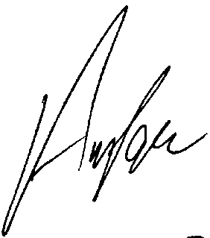

A Pope

Director